Design Rationale

This is for the Game iteration 1 of the simple tile map game by Devlan McKenzie

# Introduction

This paper will discuss the reasons behind the creation of the first iteration of the game and cover some of the methods used during its creation. This will also make reference to concepts from the previous design rationale used for the prototype. This paper will also follow the familiar rationale format to assist in this process as was done in the previous rationale.

The paper will also focus more on how the answers or knowledge learnt affect my approach to design and how my thinking of design changes during the process.

# Previous Question from Prototype Design Rationale

“The question thus became something a kin to this, can I make a basic pixel art tile set and use it to create an environment, if so can I use the environment to create a simple 2D game. What are the challenges encountered in this task and what methods are suitable for a beginner to overcome these challenges?”

This was concluded with the fact that I picked up a new skill and can now create tile sets; this allowed me to create an environment and allowed me to make a simple 2D game. I discussed the challenges faced and how to overcome them and basic pixel art concepts.

# Current Questions

The previous questions can now be more refined as I have answered some of the questions and become something like this, how could the use of limited tile sets be used to create dynamic design challenges for my player to overcome in a top down 2D game. This will hopefully reveal interesting design processes and means of creation that were previously unknown to me.

In addition to this, at what point can you say your project has reached iteration 1 and who is my audience and what does my play testing reveal.

# Process

The questions were approached with a design approach in mind which was simple, firstly think about the question critically then use the information gained to answer the who, what, why and how of the questions.

The questions were approached in this order as it made the most sense to me.

## First Question Approached

Firstly the question on iteration 1, this revealed that iteration 1 will change based on what you are trying to achieve with your questions and circumstances, in my case the further implementation of a game was required so that I could determine my audience and obtain play tester results as well as answer the limited tile set question.

This was achieved by the addition of a menu, pixel art characters and sound. The sound I got from the asset store for free and altered to better suit the game as well as the fireball sound effect from the site called free sound effects found here <https://www.freesoundeffects.com/files/download.php> . This was deemed appropriate as the question I was asking was more at what point can you say your project has reached iteration 1 and not aimed at the implementation of sound as a method of reaching iteration 1. In addition, the main questions I am trying to answer are the limited tile set, audience and playtesting questions.

## Second and Third Questions Approached

At this point the game had reached iteration level 1 and was able to aid me in answering the other aforementioned questions. The question on audience was approached as I already had a sense of who my audience was during the creation of the game and could now be refined and defined in a more structure manner with game content to support my argument. The audience I was aiming for was younger kids that were relatively new to games. This affect my design process as I made the art assets look simple and implemented basic mechanics in the game which included movement via the arrow keys or WASD keys and a mouse click. These were implemented in an attempt to make the game simpler and less intimidating to a younger newer player of games.

The question on limited tile sets could be answered from the work done in the previous submission in which I created an environment and from that a simple game. At the time I was unaware of the question however the knowledge gained during the creation of that environment and game has allowed me to answer the question. In essence the tile set I created could be considered to be limited as it only allowed for a basic terrain to be made using the Unity tile map system and consisted of 4 tiles and a later addition of 1 water tile to fill in the terrain. It was reasonable to assume that a tile set of 5 could be considered limited and thus based on the environment made I could answer the dynamic design challenges part of the question. These assets could easily be used to create a wide variety of design challenges and could even be used to create a game from a horizontal perspective like this.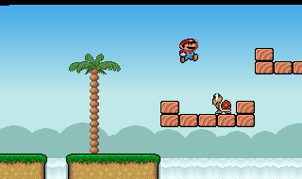

<https://www.freegameempire.com/games/Mario>

As you can see the use of tile sets can assist in many areas of creation however we will focus on the top down 2D game creation used in my game. The question reveals some interesting design processes and means of creation. Firstly the processes of design, the rotation and combination of these tiles can lead to the creation of new and unintended forms, for example the rotation of my linear floor pieces allowed me to create a hedge. 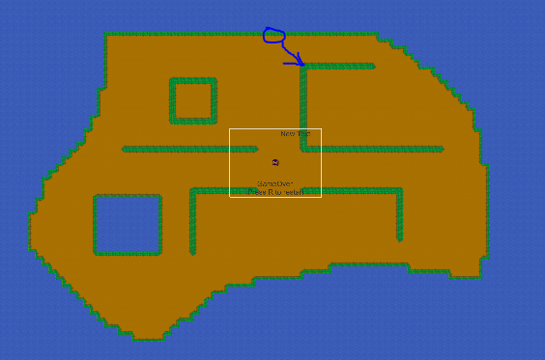

The process of creation discovered was to attempt to create art through iterative design, firstly draw it out on paper and then attempt to create it in a digital format. Simply rework the digital creation through iterations until you are happy with it. This process was used in the creation of the tile set and the pixel art characters used in the game for my player and the enemies that chase him.

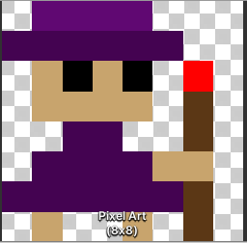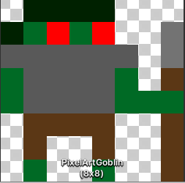

## The Final Question Approached

The final question was on the playtesting and what information it revealed; this will be used to alter the game in a future iteration. The game was found to be appropriate for younger players that are between the age of 7 and 10; the addition of the arrow keys was useful in this age bracket for newer players as they instinctively controlled the movement with the arrow keys, while the WASD keys were used by the older more experiences players. This made the game more approachable and user friendly.

The menu was said to be appropriate for the younger players as it was simple and user friendly as well. The request for more reason to move was made and a bigger stronger enemy was requested to spawn sometimes. The need for replay-ability was made apparent and a high score was requested. The addition of ammunition and melee attacks was requested as well.

Overall the players said the game was fun and appropriately complex for the target audience, the actions in the game were enjoyable.

# Reflection

In conclusion I have answered the questions proposed above, the use of creativity and iterative design in art assets was noted and has affected the way I will approach games in the future. I have learnt that using certain design approaches mentioned above will allow me to create my own art assets with relatively high success.

The term iteration 1 is dependent on the task you are trying to achieve and can vary depending on the questions you are trying to answer. In my case this was the collection of play test data, answering what my target audience was and how limited use of tile sets can create interesting design processes and means of creation. This allowed me to gauge how appropriate my game was for the target audience and what aspects of the game need to be improved on.

My target audience was adjusted and refined to be younger kids of the ages 7 to 10 and the game was deemed appropriate for them with the simple art assets and user friendly design implemented. The use of a limited tile set made it apparent that given enough time and creativity you can use art assets in a modular way and create new and unintended assets in your games. This also led to the discovery of iterative design in art which allows beginners like me to create simple art given enough time.

The play testing revealed the aforementioned and allowed me to better gauge the level of the game`s development and highlighted some issues that will be addressed in the next iteration. The main issues to be addressed will be solved by implementing more gaps in the obstacles and moving the gamer over message to the center of the screen.

# Future Plans

The immediate future plans for the game are to implement huts for the goblins to spawn on, implement all the appropriate play tester data collected, this includes the addition of gaps in the obstacles so that enemies can better follow the player and thus give the player a reason to move. The volume appears to be too sensitive and will need to be lessened. The addition of ammunition and stronger enemies will also be implemented at some point, with the addition of more attacks for the player to use. This will increase replay-ability and the addition of a high score system will further the replay-ability of the game.